**TUGAS INDIVIDU**

**PEMROGRAMAN BERBASIS FRAMEWORK**

**PERTEMUAN 11**

Disusun oleh:

**Rijal Ammar Irsyadul Ibad**

**TI-3B/2041720184**

**D4 TEKNIK INFORMATIKA**

**TEKNOLOGI INFORMASI**

**POLITEKNIK NEGERI MALANG**

**2023**

1. **Slide 3**

**Code:**

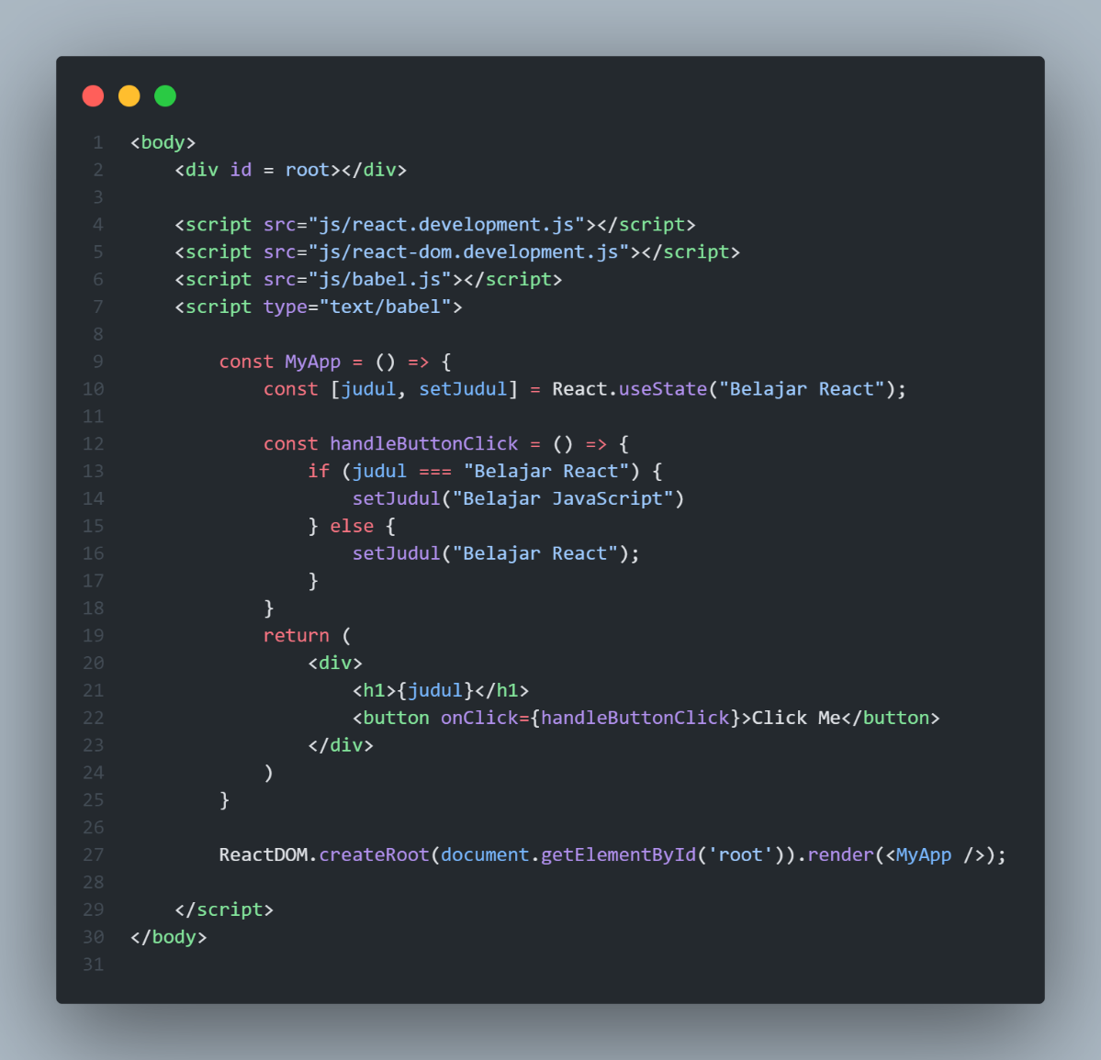

**Hasil:**

1. **Slide 5**

**Code:**

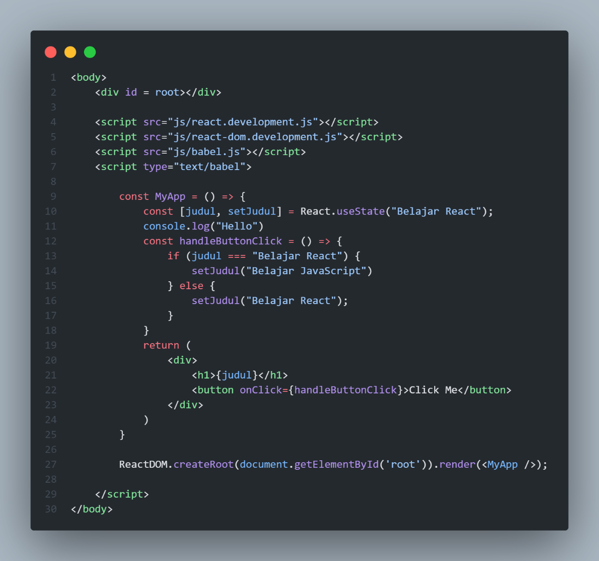

**Hasil:**

1. **Slide 6**

**Code:**

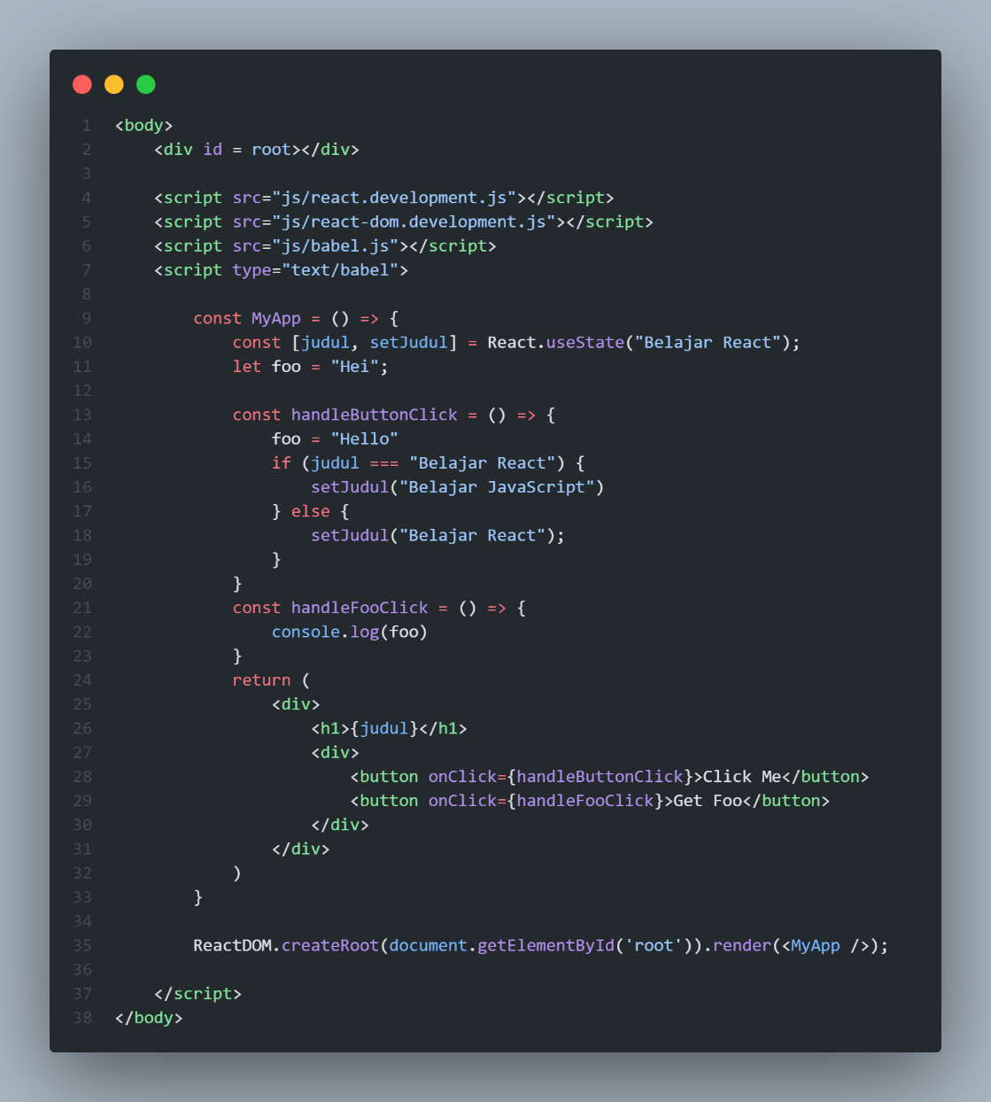

**

1. **Slide 10**

**Code:**

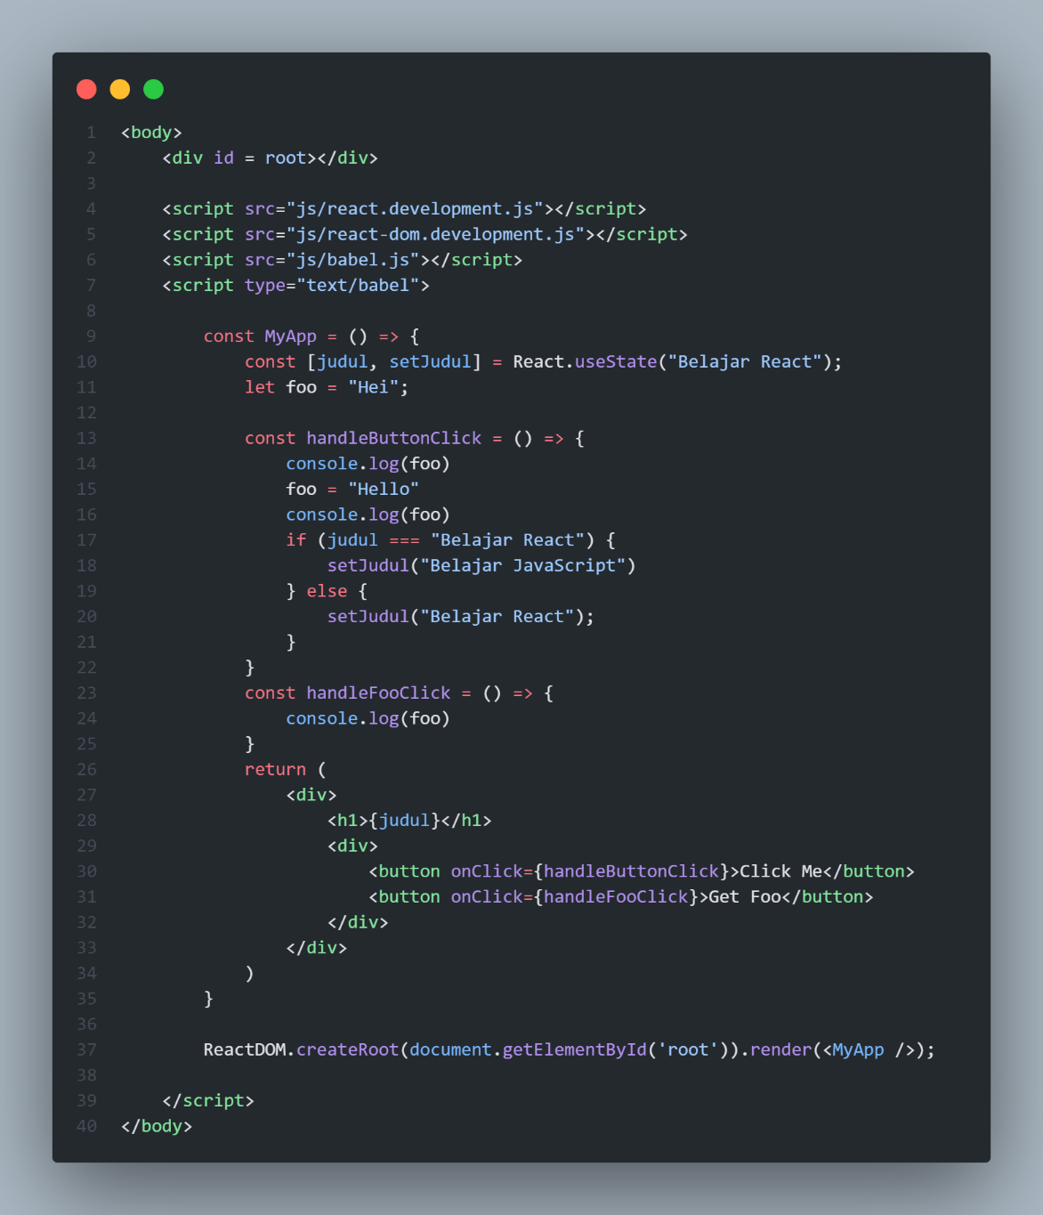

**Hasil:**

1. **Slide 13**

**Code:**

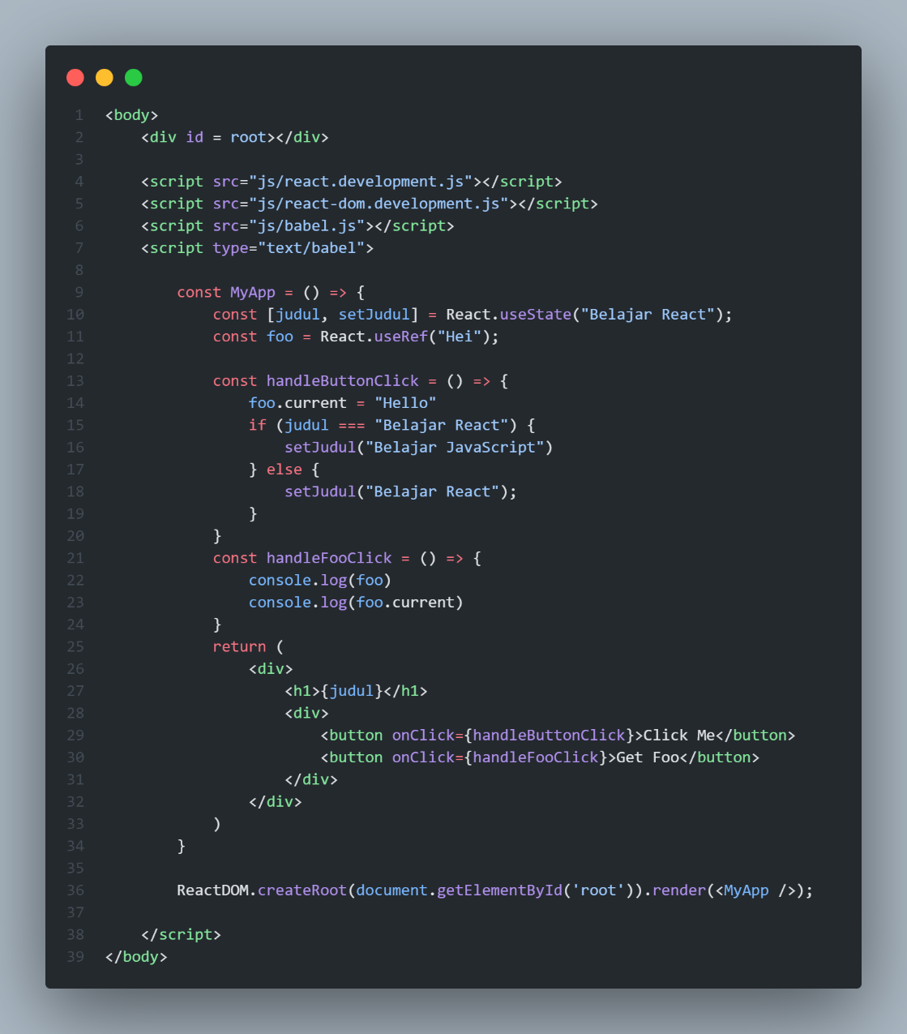

**Hasil:**

1. **Slide 15**

**Code:**

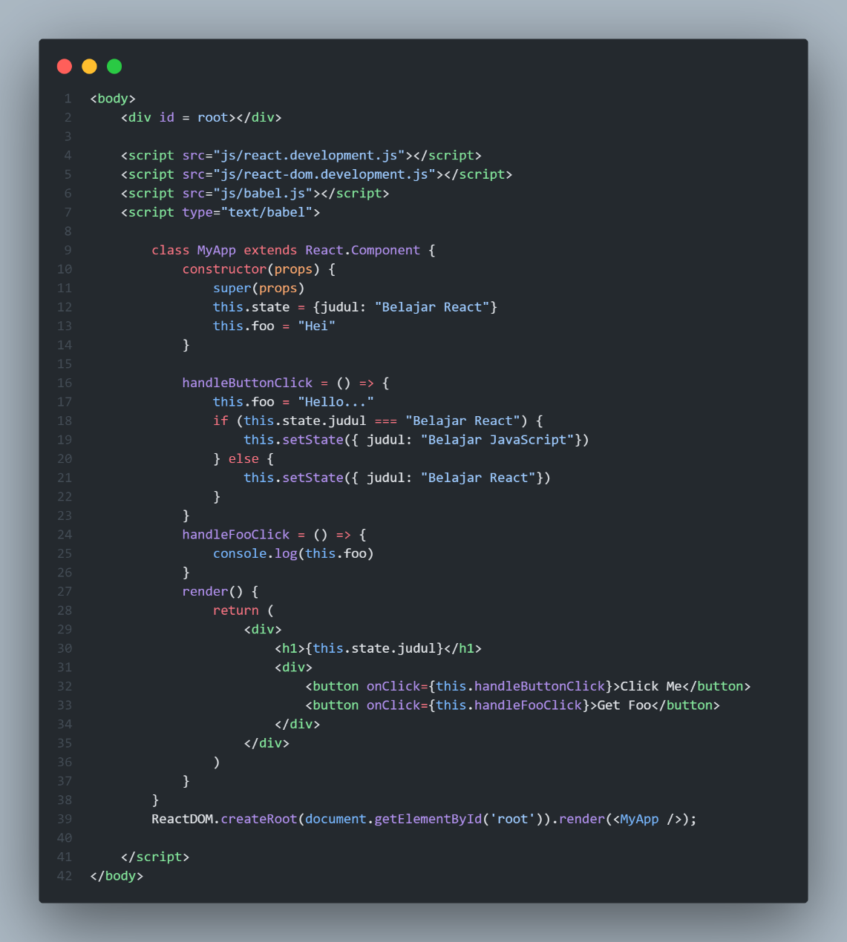

**Hasil:**

1. **Slide 19**

**Code:**

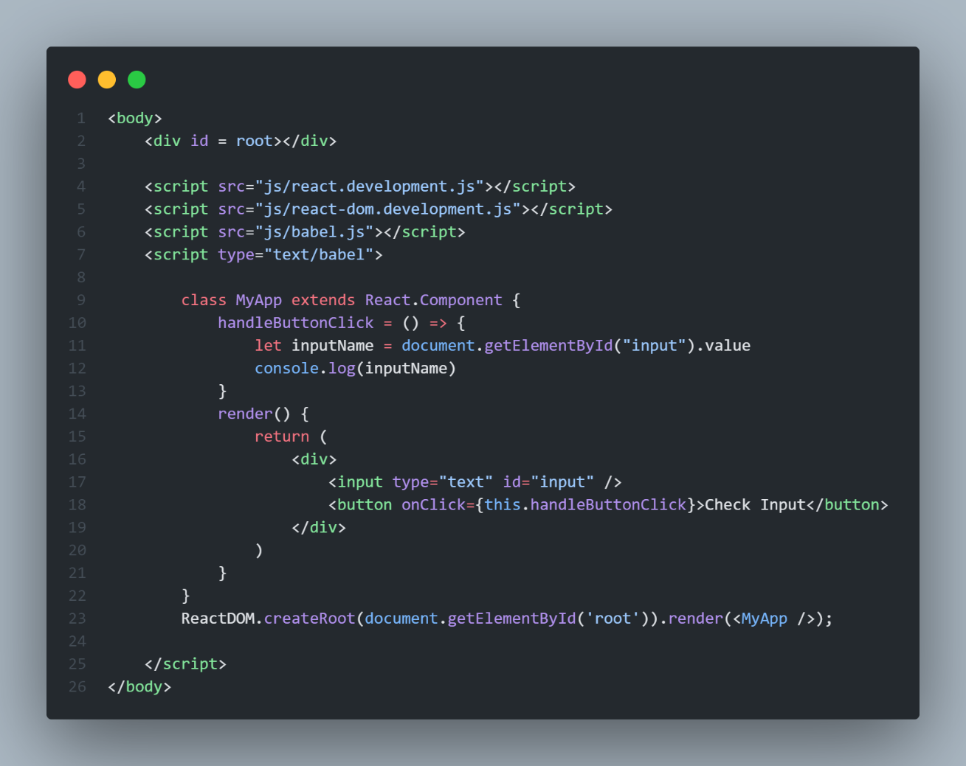

**Hasil:**

1. **Slide 23**

**Code:**

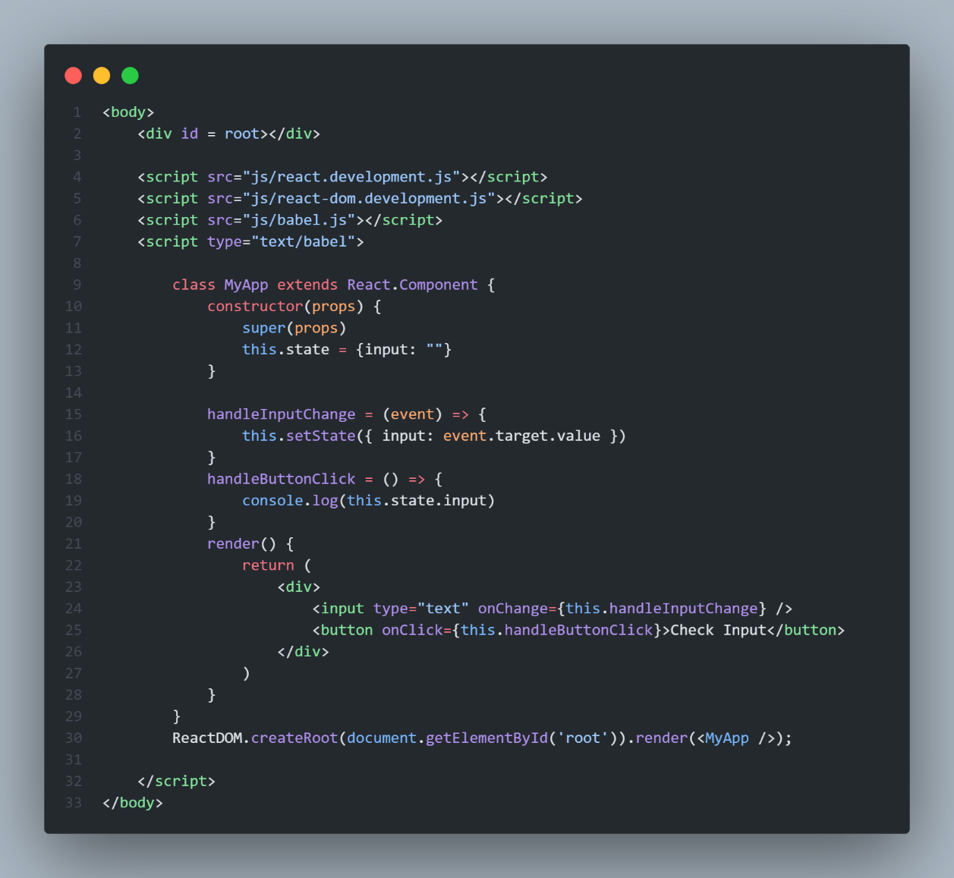

**Hasil:**

1. **Slide 26**

**Code:**

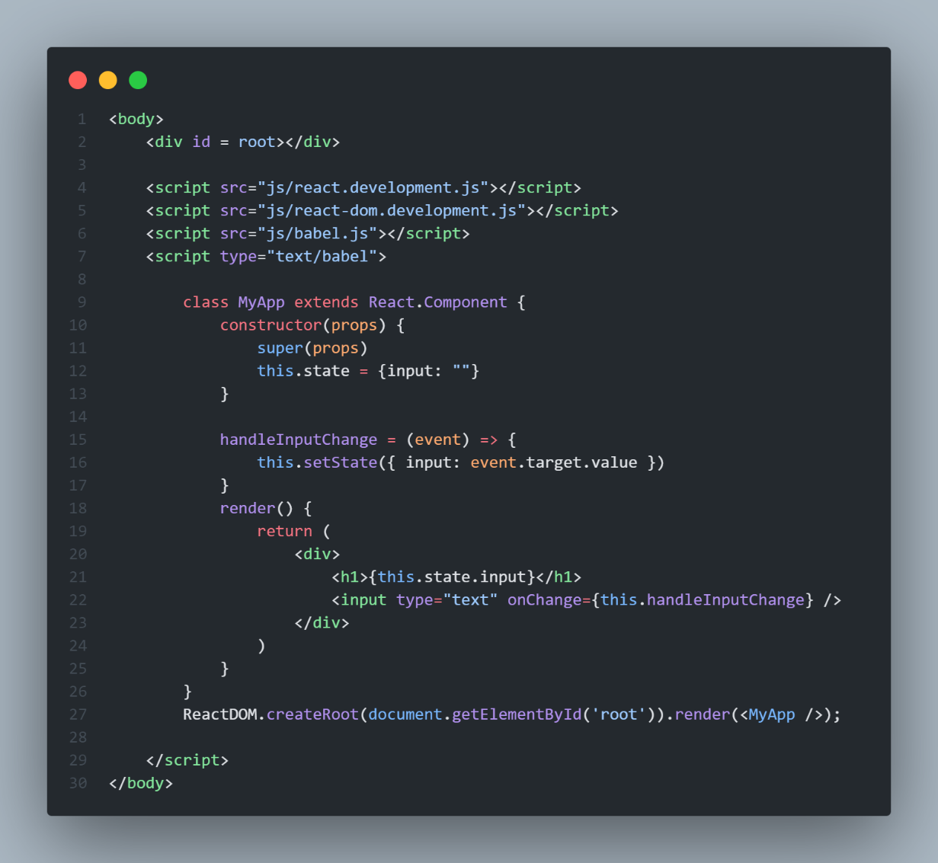

**Hasil:**

1. **Slide 29**

**Code:**

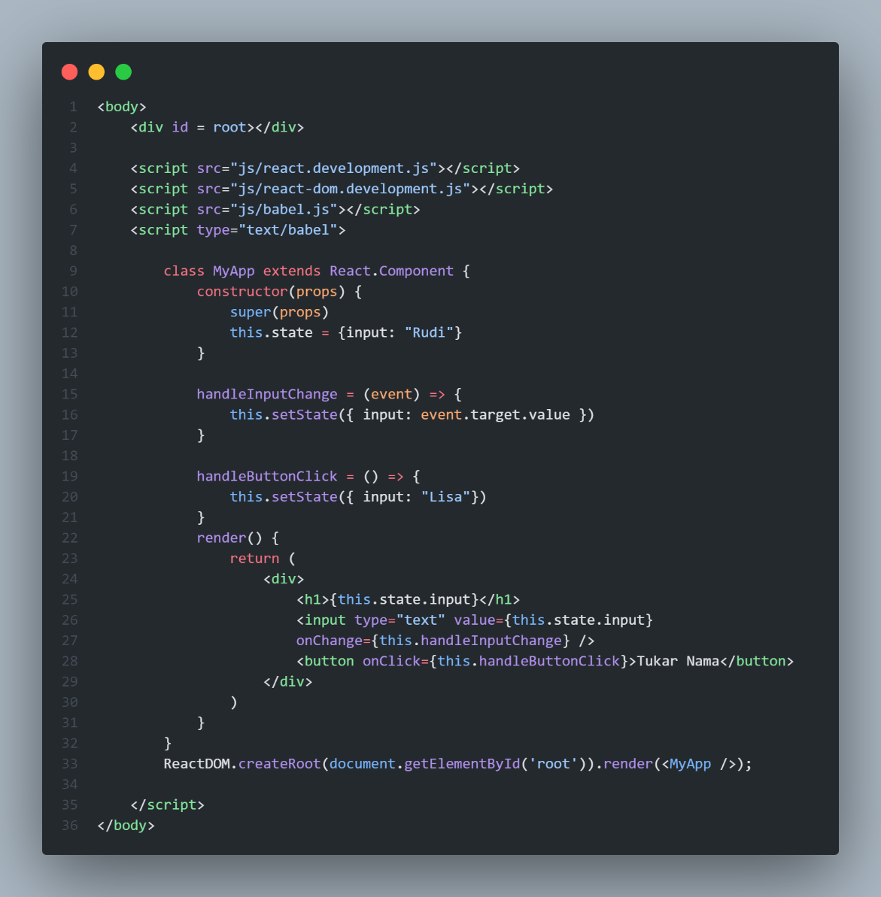

**Hasil:**

1. **Slide 34**

**Code:**

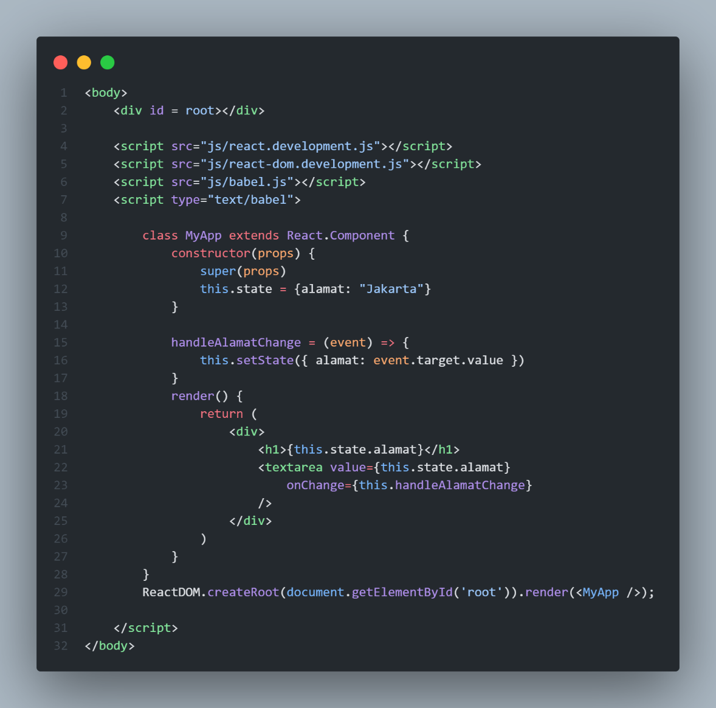

**Hasil:**

1. **Slide 38**

**Code:**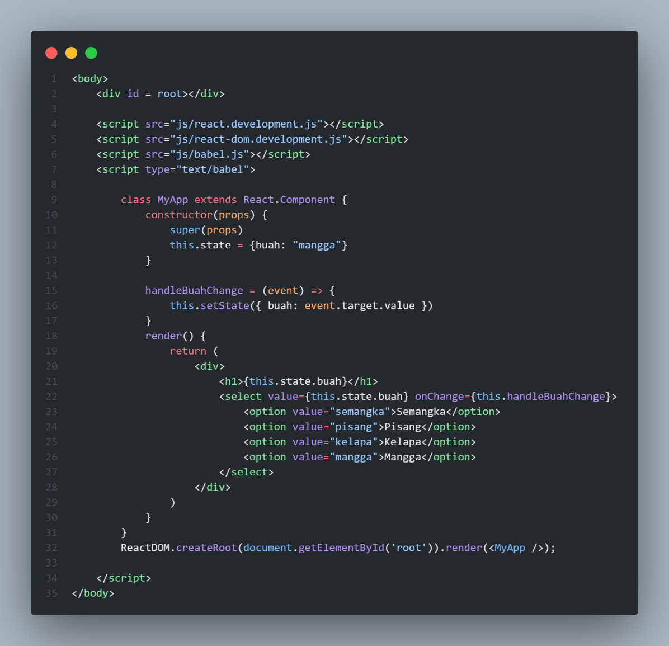

**Hasil:**

1. **Slide 40**

**Code:**

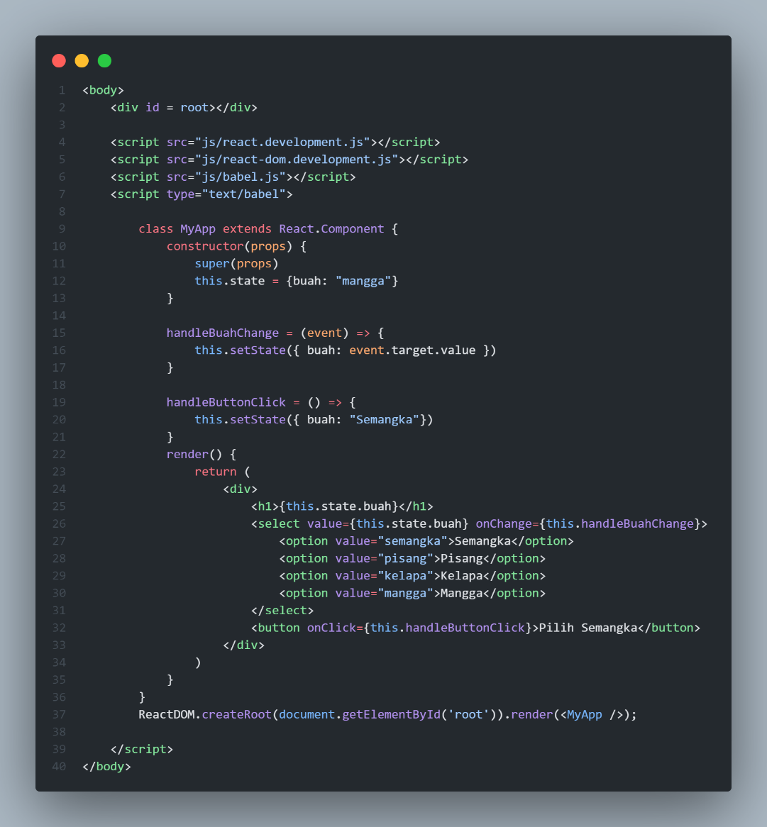

**Hasil:**

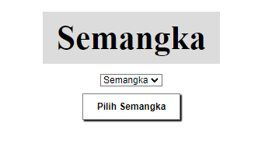

1. **Slide 42**

**Code:**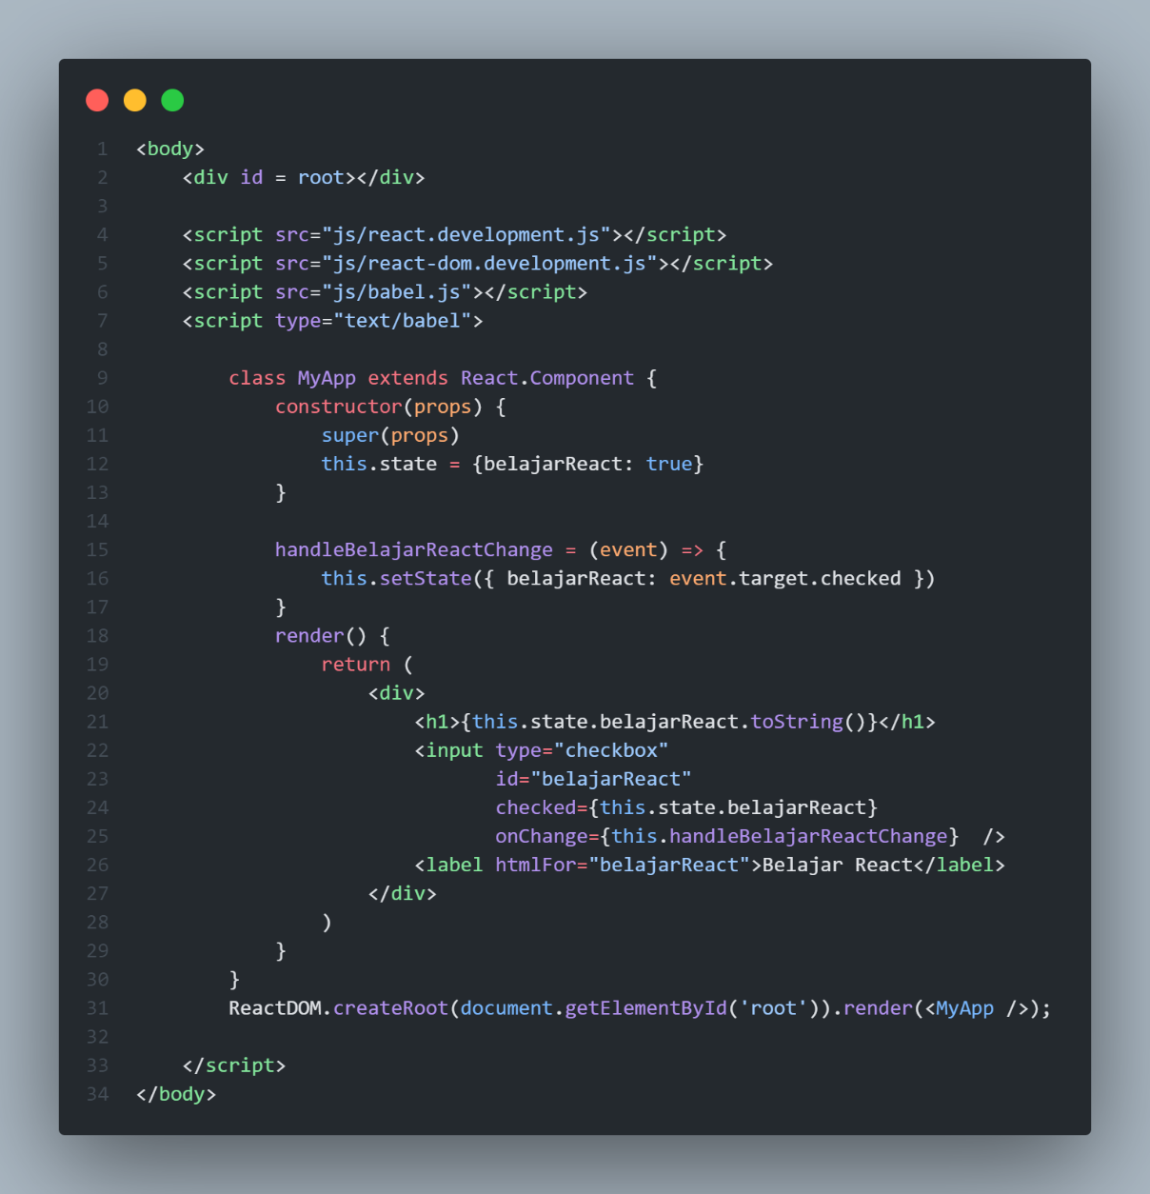

**Hasil:**

1. **Slide 45**

**Code:**

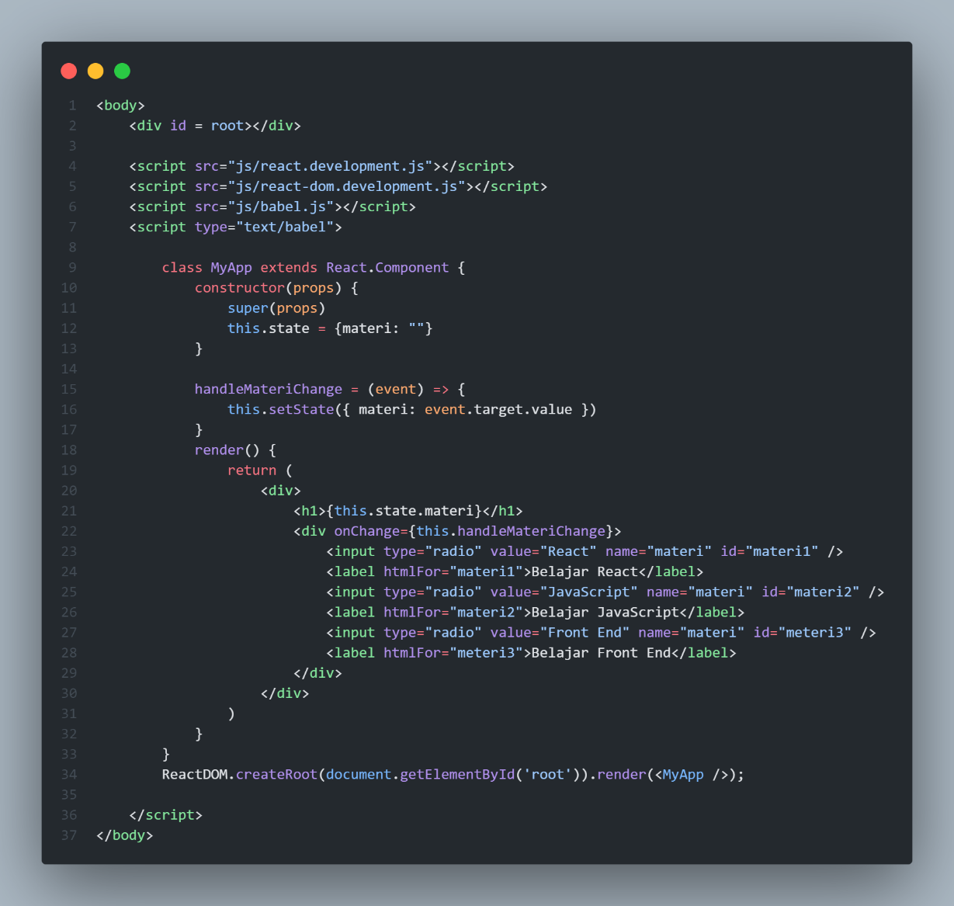

**Hasil:**

1. **Slide 48**

**Code:**

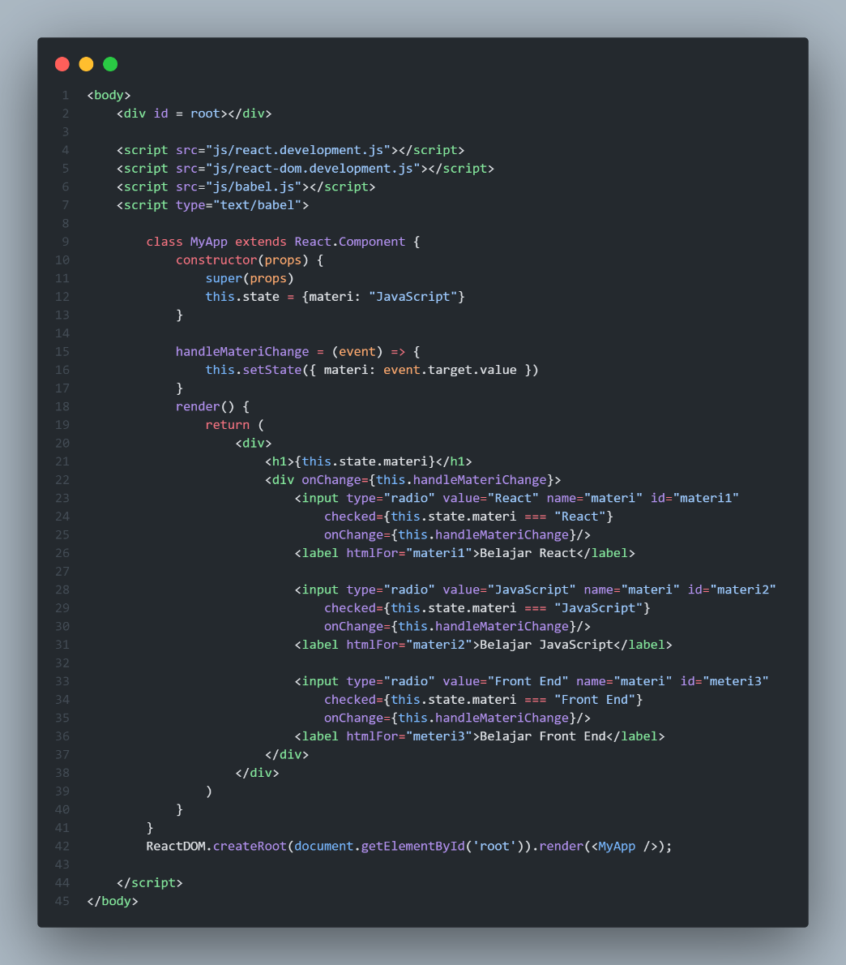

**Hasil:**

1. **Slide 51**

**Code:**

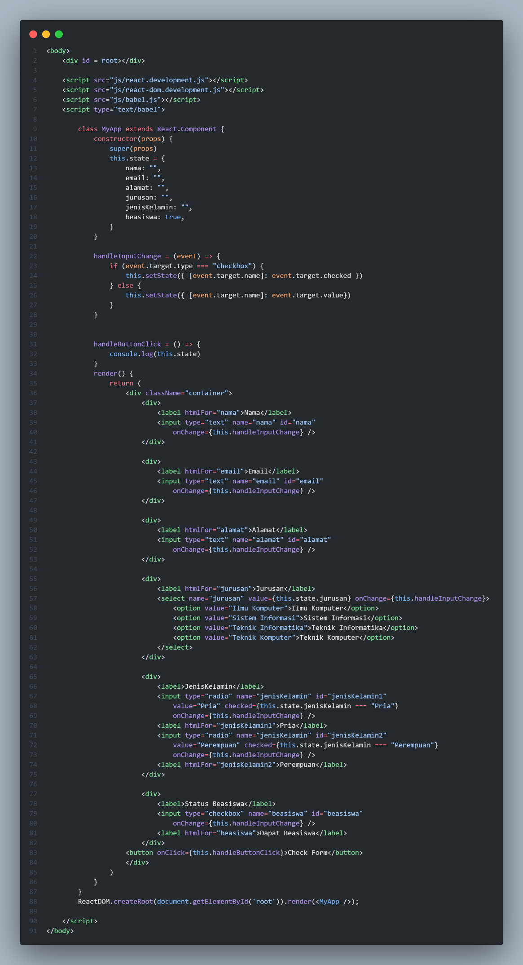

**Hasil:**

1. **Slide 58**

**Code:**

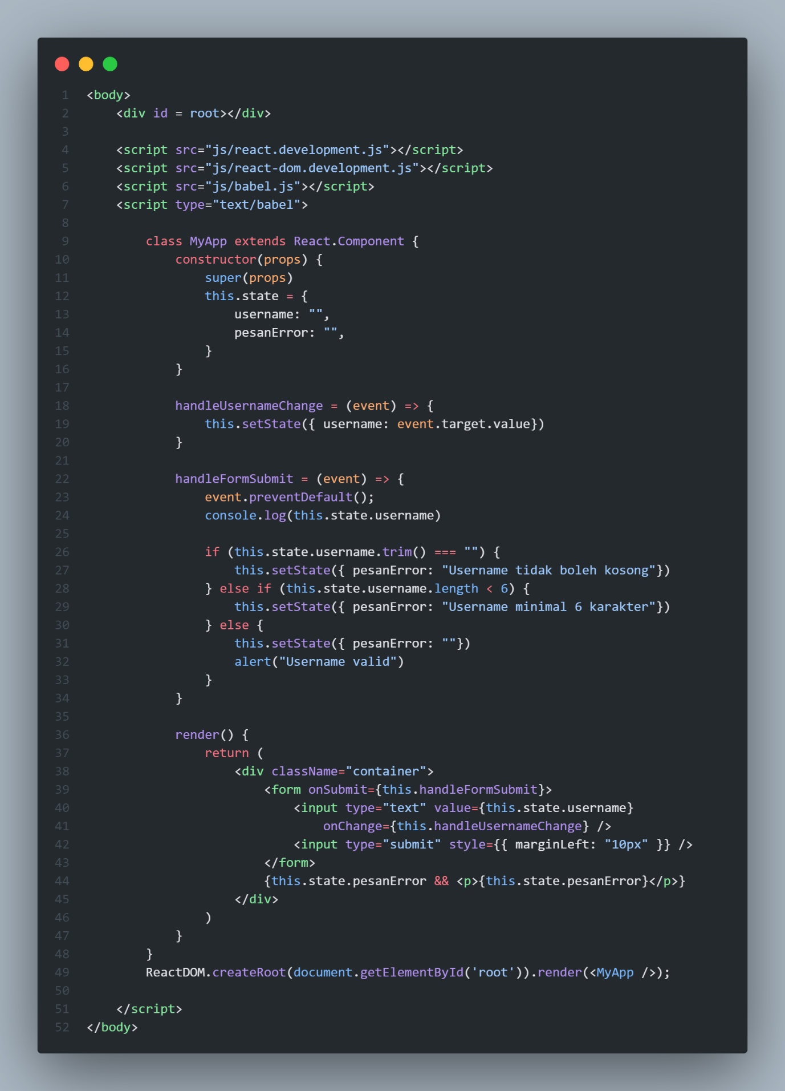

**Hasil:**

1. **Slide 64**

**Code:**

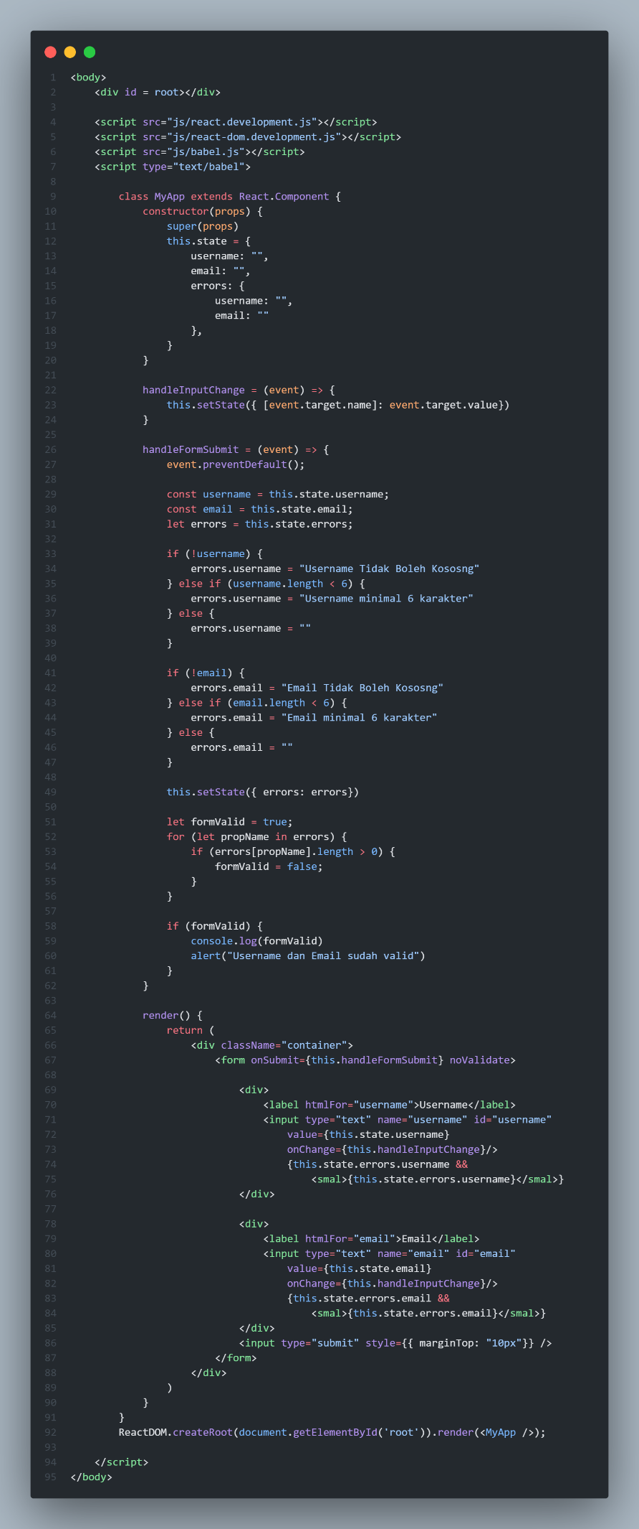

**Hasil:**

1. **Slide 66**

**Code:**

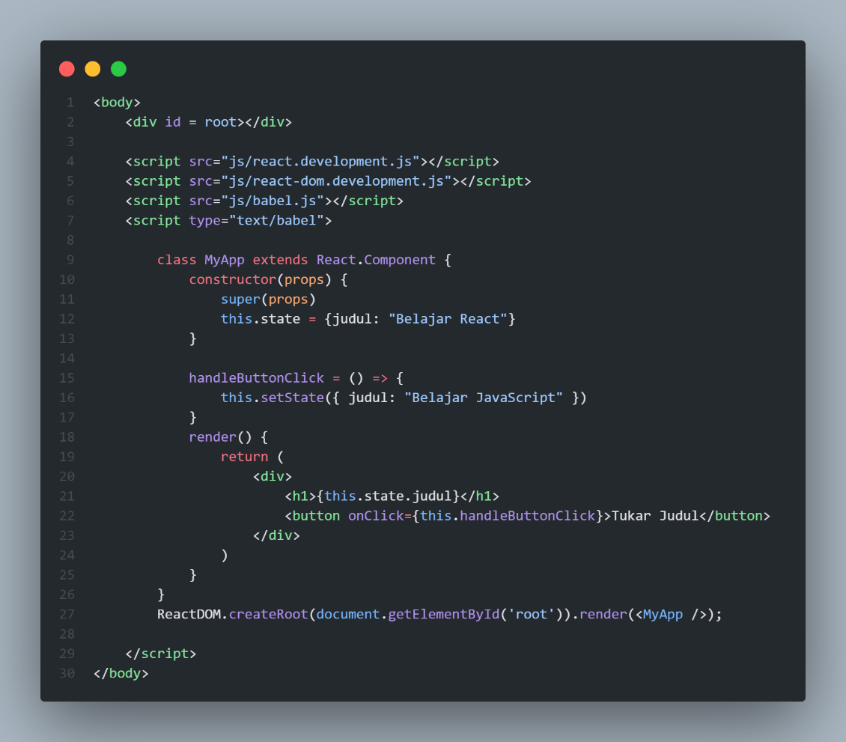

**Hasil:**

1. **Slide 68**

**Code:**

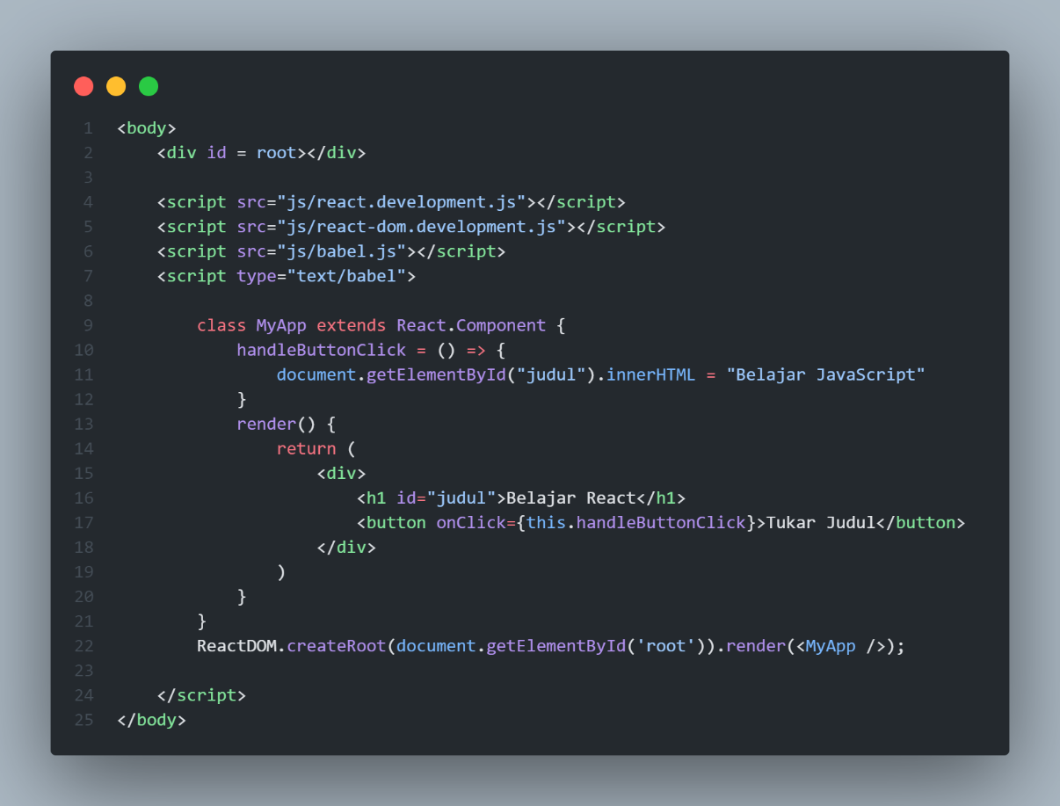

**Hasil:**

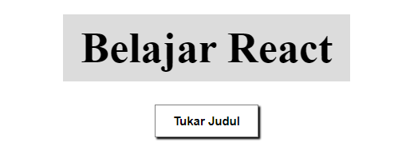

1. **Slide 69**

**Code:**

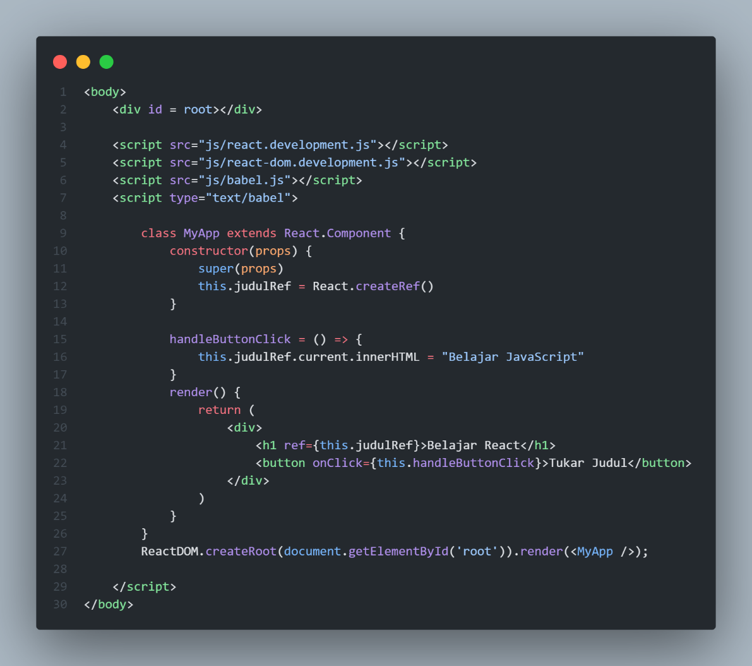

**Hasil:**

1. **Slide 71**

**Code:**

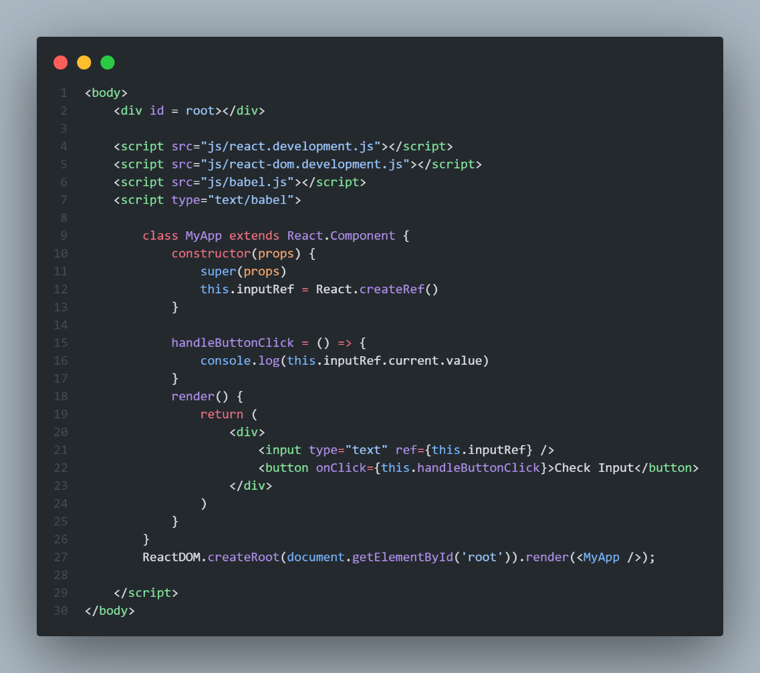

**Hasil:**

